| No. of Pages | **4** |
| --- | --- |
| No. of Questions | **3** |



**Department of Computer Science and Engineering**

**MIDTERM EXAMINATION Summer 2018**

**CSE421: Computer Network**

**Total Marks: 45 Time Allowed: 50 minutes**



* Answer ALL **THREE (3)** questions
* Figure in bracket [] next to each question indicates marks for that question



**Question 1**

1. An organization is given the block **197.12.96.0/23**. The organization takes this block to distribute to **three sub-networks** and **2 WAN-Links** as shown in the **Figure No. 1** below. Show how you can efficiently distribute the given block to create the required subnets using VLSM. Show basic calculations. **[10 Marks]**

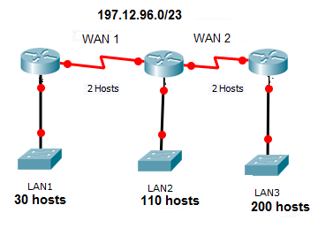



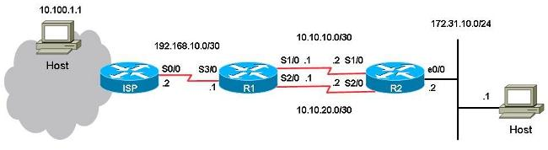

1. Refer to the topology in **Figure 2** above. Since this is a stub network, static routes are preferable.

**ip route 172.31.10.0 255.255.255.0 _______________**

* 1. The above static route command should be implemented in which router/s and what should be written in the blank line?
  2. To create a floating static route for 172.31.10.0 network, what are the modifications to be done in the above command and in which router/s will you implement it? [2+3 marks]

**Question 2**

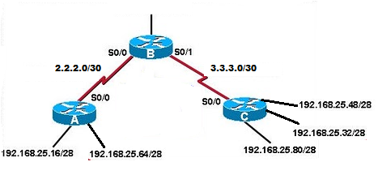

1. Refer to **Figure no.3.** For both Router A and Router C auto-summary is enabled. What kind of problem will this create for Router B and how do we solve this problem? [4+1marks]
2. A router learns a route to 200.32.16.0/24 from its neighbour, that it is 5 hops away. Suddenly it stops receiving updates regarding this route to 200.32.16.0/24 network from its neighbour.
   1. What will it do if it does not receive any route update of 200.32.16.0/24 in the next 6 updates from its neighbour? [4 marks]
   2. What will the router do if it still does not receive any update for 200.32.16.0/24 network by the 8th update sent by its neighbour? [2 marks]
3. Refer to the **Figure No.4** below. All routers are running RIPv2, packets from PCB to PCA will take which route and why? [4 marks]

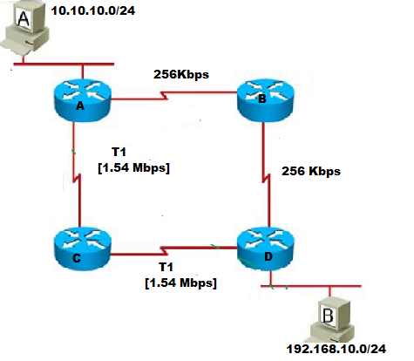

**Question 3**

1. Differentiate between Hello packets and Database Description Packets/ Link State Packets. [3 marks]

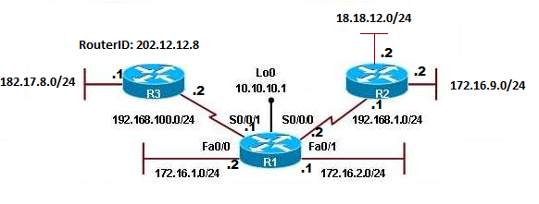 

1. Refer to **Figure no. 5**. Determine the router IDs for router R1, R2 and R3. Why is recommended not to use the physical interface’s IP address as the Router ID? [3+3 marks]

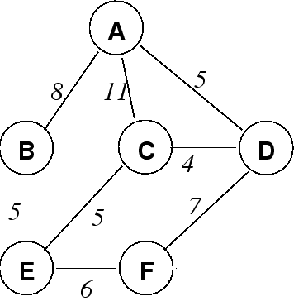

1. Link state routing protocol uses Dijkstra’s algorithm. Now using Dijkstra’s algorithm, compute the shortest path from Node C to all other remote networks shown in **Figure no.6**. Use the table provided. [6 marks]



**THE END**

**Question 3 (c)**

**SET A**

| Step No. | N’ |  |  |  |  |  |
| --- | --- | --- | --- | --- | --- | --- |
|  |  |  |  |  |  |  |
|  |  |  |  |  |  |  |
|  |  |  |  |  |  |  |
|  |  |  |  |  |  |  |
|  |  |  |  |  |  |  |
|  |  |  |  |  |  |  |
|  |  |  |  |  |  |  |
|  |  |  |  |  |  |  |
|  |  |  |  |  |  |  |
|  |  |  |  |  |  |  |
|  |  |  |  |  |  |  |
|  |  |  |  |  |  |  |
|  |  |  |  |  |  |  |

